  - PROTOTYPE MODEL:
The Prototype Model that involves creating a prototype of the system or application before building the actual product.
Phases:
- Requirements gathering: Identify the basic requirements of the system
- Quick design: Create a basic design of the system.
- Build prototype: Build a working prototype of the system.
- User evaluation: Test the prototype with users to gather feedback.
- Refine prototype: Refine the prototype based on user feedback.
- Implement final system: Build the final system based on the refined prototype.

Advantages:
- Improved user satisfaction
- Early detection of errors
- Reduced risk
- Increased flexibility

Dis-advantages:
- Can be time-consuming and costly
- May lead to scope creep
- Requires significant user involvement

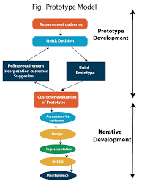
  - Iterative model:
The Iterative Model that emphasizes iterative and incremental development. It involves breaking down the development process into smaller cycles, with each cycle building on the previous one.
Phases:
- Planning: Define project scope, goals, and deliverables.
- Analysis: Gather requirements and define system specifications.
- Design: Create a detailed design of the system.
- Implementation: Develop and test the system.
- Testing: Test the system and identify defects.
- Deployment: Deploy the system to production.
- Evaluation: Review and assess the system
Advantages:
- Flexibility to changing requirements.
- Reduced risk
- Continuous improvement
- Improved customer satisfaction
- Faster time-to-market
Dis-advantages:
- Requires significant customer involvement
- Can be challenging to manage and co-ordinate
- May lead to scope creep if not managed properly
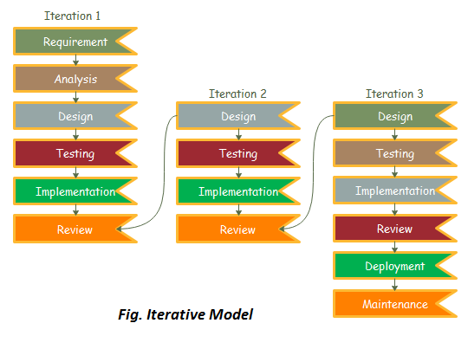
Spiral Model:
The Spiral Model is that combines elements of both iterative and waterfall models. It is a risk-driven approach that emphasizes incremental releases and continuous improvement.
Phases:
- Planning: Define goals, objectives, and Deliverables.
- Risk Analysis: Identify and mitigate potential risks.
- Engineering: Develop and test the system.
- Evaluation: Review and assess the system.
Advantages:
- Reduces risk by identifying and mitigating potential issues early
- Allows for continuous improvement and adaptation to changing requirements
- Encourages customer involvement and feedback
- Supports iterative and incremental development
Dis-advantages:
- Requires significant customer involvement
- Can be complex and difficult to manage
- May lead to scope creep if not managed properly

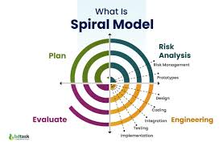

  - Rapid Application Development Model:
  - The Rapid Application Development Model that emphasizes rapid development and delivery of a working system. It is an iterative and incremental approach that focuses on quick development and continuous improvement.
Phases:
- Planning: Define goals, objectives, and Deliverables.
- User design: Gather requirements and create prototypes.
- Rapid construction: Develop and test the system.
- Cutover: Deploy the system to production.
- Maintenance: Refine and improve the system.
Advantages:
- Fast development and delivery
- Improved user satisfaction
- Reduced risk
- Increased flexibility
- Encourage user involvement
Dis-advantages:
- Requires significant customer involvement
- Can be challenging to manage and co-ordinate
- May lead to scope creep if not managed properly

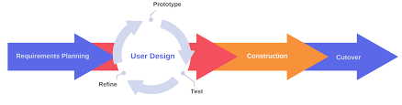
Fig: Rapid Application Development Model

